Boundary Point
# Source: AI Source: Provided by: [Data Path: Persons Table -> ID Column: 1, Name_En Column: Motasem Essam] -> From: [ChatGPT] on [7/25/2026]
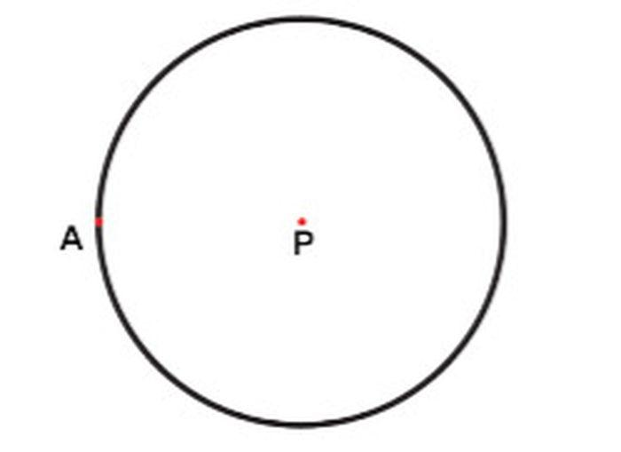
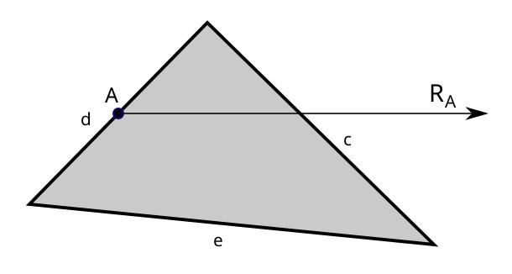
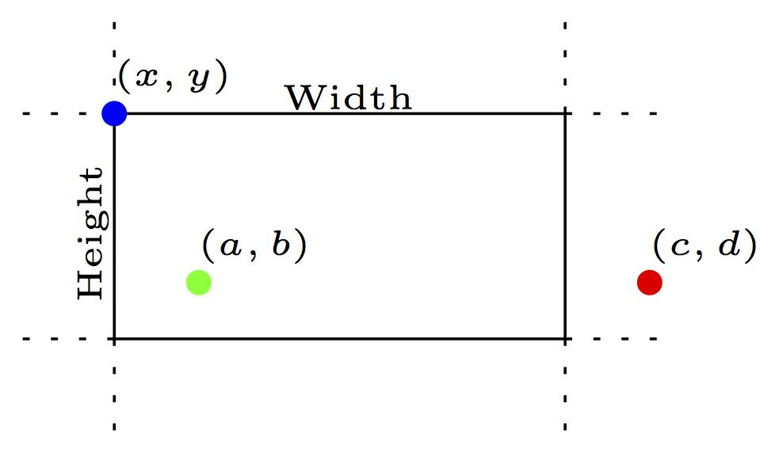
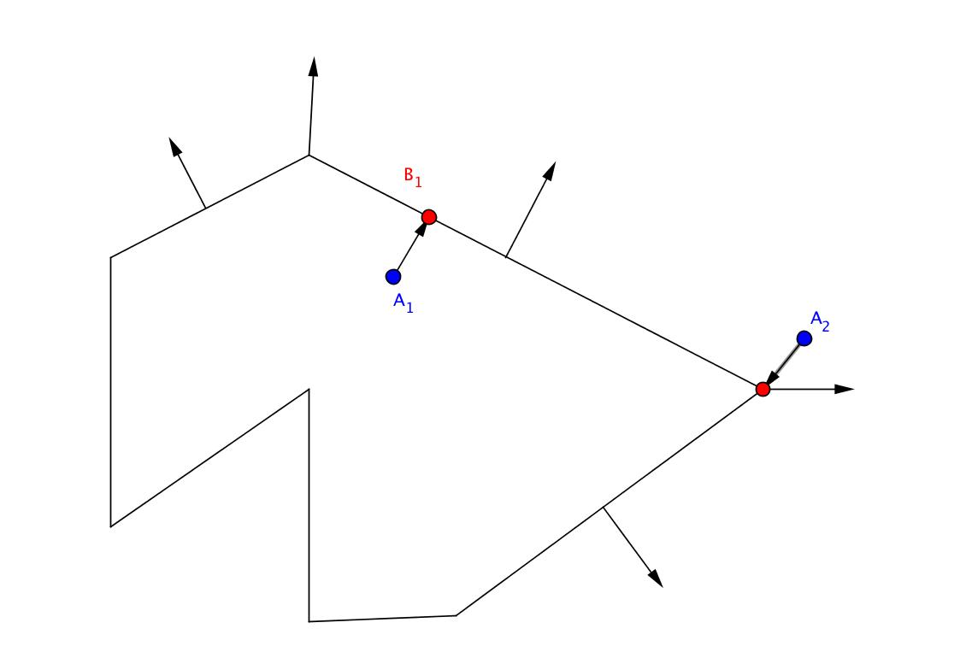

Definition
# Source: AI Source: Provided by: [Data Path: Persons Table -> ID Column: 1, Name_En Column: Motasem Essam] -> From: [ChatGPT] on [7/25/2026]
A Boundary Point is a point that lies exactly on the boundary (edge or border) of a geometric figure or region. It separates the interior of the figure from the exterior.
A boundary point belongs to the figure's boundary but is not considered an interior point.

Characteristics
# Source: AI Source: Provided by: [Data Path: Persons Table -> ID Column: 1, Name_En Column: Motasem Essam] -> From: [ChatGPT] on [7/25/2026]
A boundary point:
- Lies exactly on the edge or border of a figure.
- Separates the interior from the exterior.
- Belongs to the figure's boundary.
- Is neither completely inside nor completely outside the figure.
- Exists in both two-dimensional and three-dimensional geometric objects.

Illustration
# Source: AI Source: Provided by: [Data Path: Persons Table -> ID Column: 1, Name_En Column: Motasem Essam] -> From: [ChatGPT] on [7/25/2026]
Boundary Point on a Triangle
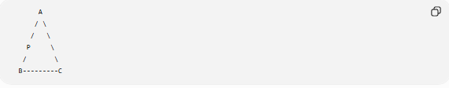
A
/ \
/ \
P \
/ \
B---------C
Point P lies on side AB, so it is a boundary point.

Boundary Point on a Circle
# Source: AI Source: Provided by: [Data Path: Persons Table -> ID Column: 1, Name_En Column: Motasem Essam] -> From: [ChatGPT] on [7/25/2026]
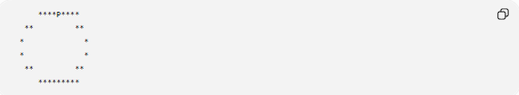
****P****
** **
* *
* *
** **
*********
Point P lies on the circumference of the circle, making it a boundary point.

Mathematical Description
# Source: AI Source: Provided by: [Data Path: Persons Table -> ID Column: 1, Name_En Column: Motasem Essam] -> From: [ChatGPT] on [7/25/2026]
For a geometric figure $F$:
A point $P$is a boundary point if every neighborhood around $P$contains:
- Points belonging to the figure, and
- Points outside the figure.
Symbolically:
$$P∈∂F$$
where:
- $∂F$denotes the boundary of the figure.

Examples
# Source: AI Source: Provided by: [Data Path: Persons Table -> ID Column: 1, Name_En Column: Motasem Essam] -> From: [ChatGPT] on [7/25/2026]
Boundary points can lie on the edges of:
- Triangle
- Rectangle
- Square
- Circle (circumference)
- Polygon
- Ellipse
- Solid objects (surface)

Properties
# Source: AI Source: Provided by: [Data Path: Persons Table -> ID Column: 1, Name_En Column: Motasem Essam] -> From: [ChatGPT] on [7/25/2026]
A boundary point:
- Belongs to the boundary of a figure.
- Touches both the interior and exterior regions.
- May serve as:
  - A vertex
  - An endpoint
  - A point on an edge or curve
- Is important in defining closed geometric figures.

Applications
# Source: AI Source: Provided by: [Data Path: Persons Table -> ID Column: 1, Name_En Column: Motasem Essam] -> From: [ChatGPT] on [7/25/2026]
Boundary points are used in:
- Geometry
- Topology
- Computational Geometry
- Computer Graphics
- CAD (Computer-Aided Design)
- GIS (Geographic Information Systems)
- Robotics
- Collision Detection
- Finite Element Analysis (FEA)

Advantages
# Source: AI Source: Provided by: [Data Path: Persons Table -> ID Column: 1, Name_En Column: Motasem Essam] -> From: [ChatGPT] on [7/25/2026]
Using boundary points helps to:
- Define the limits of geometric figures.
- Separate interior and exterior regions.
- Support geometric proofs.
- Improve computational geometry algorithms.
- Model real-world boundaries accurately.

Limitations
# Source: AI Source: Provided by: [Data Path: Persons Table -> ID Column: 1, Name_En Column: Motasem Essam] -> From: [ChatGPT] on [7/25/2026]
Boundary points:
- Depend on the precise definition of the figure.
- May require computational methods to determine for complex or irregular shapes.

Comparison with Other Types of Points
# Source: AI Source: Provided by: [Data Path: Persons Table -> ID Column: 1, Name_En Column: Motasem Essam] -> From: [ChatGPT] on [7/25/2026]
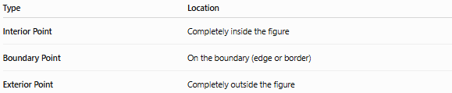
Type | Location
Interior Point | Completely inside the figure
Boundary Point | On the boundary (edge or border)
Exterior Point | Completely outside the figure

Key Points
# Source: AI Source: Provided by: [Data Path: Persons Table -> ID Column: 1, Name_En Column: Motasem Essam] -> From: [ChatGPT] on [7/25/2026]
- A Boundary Point lies exactly on the edge or border of a geometric figure.
- It separates the interior from the exterior.
- It belongs to the figure's boundary.
- Examples include:
  - A point on the side of a triangle
  - A point on the circumference of a circle
  - A point on the edge of a polygon
- Boundary points are fundamental in geometry, topology, CAD, GIS, computer graphics, and computational geometry.

Conclusion
# Source: AI Source: Provided by: [Data Path: Persons Table -> ID Column: 1, Name_En Column: Motasem Essam] -> From: [ChatGPT] on [7/25/2026]
A Boundary Point is a point located precisely on the edge or border of a geometric figure, forming the interface between its interior and exterior regions. It is essential for defining the limits of geometric objects and plays a crucial role in geometry, topology, computational geometry, engineering, computer graphics, CAD, GIS, robotics, and scientific modeling, where accurately identifying and analyzing boundaries is fundamental.

